Reynolds United Methodist Church
September 2 – 15th Sunday after Pentecost
______________________________________________________________

Gathering

Greeting

The All Church Memory Verse of the Month: Ezekiel 37:14 (NIV)
“I will put my Spirit in you and you will live, and I will settle you in your own land. Then you will know that I the Lord have spoken, and I have done it, declares the Lord.’” ~ Ezekiel 37:14

Voices In Praise “Show Me Your Glory” ~ Third Day

Proclaiming God’s Word

Children’s Moment: Pastor Seamus
Scripture Lesson: Revelation 1:1-3, 9-16
Message Sermon Series: The Great Uncovering
“Lord of Past, Present, & Future” Pastor Seamus

Responding to The Word

The Great Thanksgiving w/The Lord’s Prayer

Holy Communion

Sharing of Joys & Concerns

Pastoral Prayer

Presentation of Tithes and Offerings
Offertory “Swing Low, Sweet Chariot” ~ The Lower Lights
Singing of Our Doxology (UMH 95)

Dedication of the Offering

Sending Forth (Going into the world/into the week)
Announcements (See Bulletin, below)
Sending Song: “You Are God Alone” ~ Phillips, Craig, & Dean

Benediction

Postlude

CHURCH CALENDAR
Wednesday, September 5 – 9:30-11 am, Bible Study, Read Revelation, chapter 2-3
Sunday, September 9 – Rally Day/VBS Reunion
Monday, September 10 – Ministry Council Meeting, 7 pm
Wednesday, September 12 – Singing in Franklin Grove

ANNOUNCEMENTS
Our Mission focus for September is part of the Yellow Band in our Rainbow Covenant giving. Conference Advance #123615 is support for Tree of Life Ministry serving the people of the Rosebud Reservation in South Dakota. Mark your checks “M.O.M.” or “Tree of Life” to support this ministry.

Football Season is almost here and Reynolds Church has the opportunity to feed the AFC Football Team again this year! We are signed up for Thursday, October 4th and plan to provide a full Turkey Dinner! More details to come, but if you would like to help or provide any of the food, please contact Kathy Becker or Cindy Knight. Thank you!

The NIC General/Jurisdictional Delegation will be holding listening and conversation sessions this fall. You can choose to attend any one of the locations. The DeKalb District session will be held on October 6 at 1 pm at Wesley UMC in Sterling.

If you would like your college student to receive cards and/or care packages, please give his/her school address to Rhonda Brown by September 9th so we can share it in the bulletin. Thank you!

Our Annual Church Conference has been scheduled for Monday, November 5th at 7 pm.
SPRC will meet at 6:30. All are invited to attend. Request for Annual reporting will be forthcoming shortly, please prepare to submit reports to the Church office by October 15. Thank you!

To submit items for the newsletter, please email Kathy Clark; kathleenaclark@comcast.net

Serving this Sunday, September 2
Ushers for September: Alex Cheeseman, Bob Cheeseman, Duane Ackland, Vern Gittleson
Greeters: Bob & Lois Heimbaugh

Liturgist: TBD

Youth Moment: Pastor Seamus

Children Church Teacher: Summer break

Children’s Church Shepherd: Summer break

Communion Steward September: Kathy Becker

Church Hostess for September: Contact Pastor Seamus

Coffee Fellowship Time: Penny & Denny Bennett

Lawn Mowing: Dusty Horner

Serving next Sunday, September 9
Ushers for September: Alex Cheeseman, Bob Cheeseman, Duane Ackland, Vern Gittleson
Greeters: TBD

Liturgist: TBD

Youth Moment: Rhonda Brown

Children Church Teacher: Jane Rueff

Children’s Church Shepherd: Volunteer needed

Communion Steward September: Kathy Becker

Church Hostess for September: Contact Pastor Seamus

Coffee Fellowship Time: Rally Day/VBS Reunion Potluck

Lawn Mowing: Jason Riddell

Last week’s Offering: Church Fund 1,724.00
VBS 20.00
Zambia 15.00

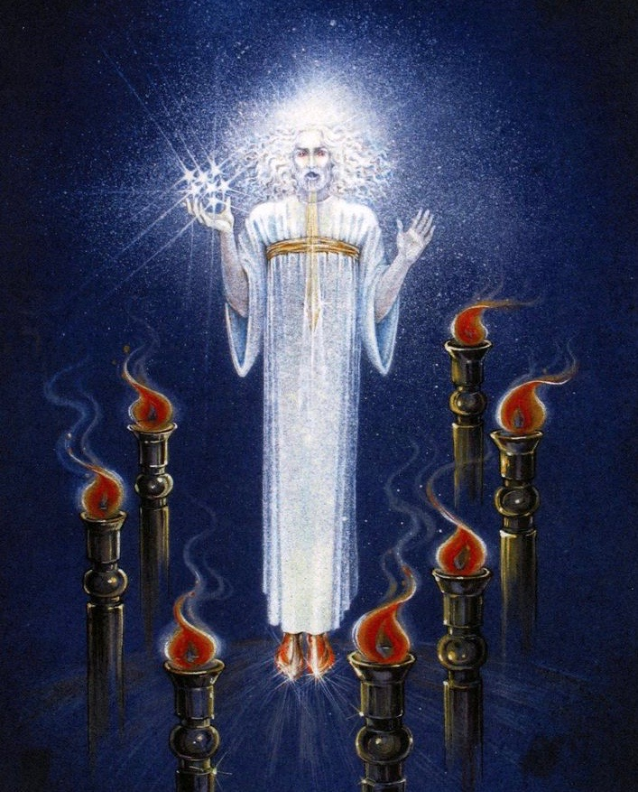

Reynolds United Methodist Church
2496 Reynolds Road
Ashton, IL 61006
(815) 453-2513
E-mail: reynoldsumc@oglecom.com
Web Site: www.reynoldsumc.net
Pastor: Seamus Enright

